postOperationPresentSostav

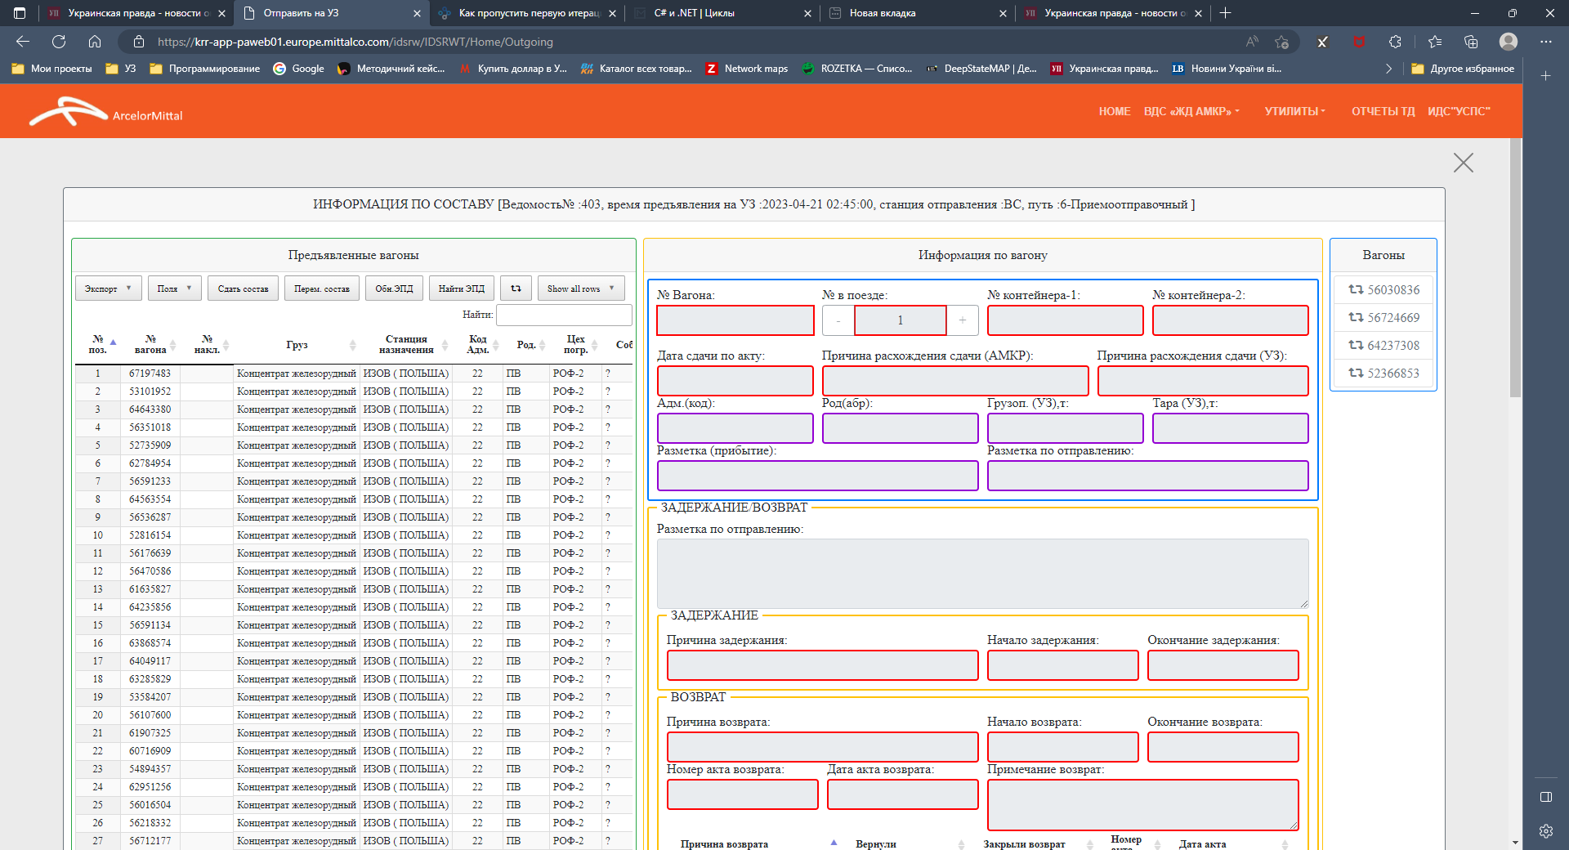

Модуль **table_outgoing_cars**



Показать вагоны

this.ids_wsd.getViewOutgoingCarsOfIDSostav(this.id_sostav, function (wagons) {}) (api/ids/rwt/outgoing_cars/view/sostav/id/6)

-> IDS_RWT_WSDController: GetViewOutgoingCarsOfIDSostav(int id) -> select * from [IDS].[get_view_outgoing_cars_of_id_sostav](@id_station) order by outgoing_car_position

Кнопки

«сдать состав»

вызывает форму модуль **form_ho_outgoing_sostav**

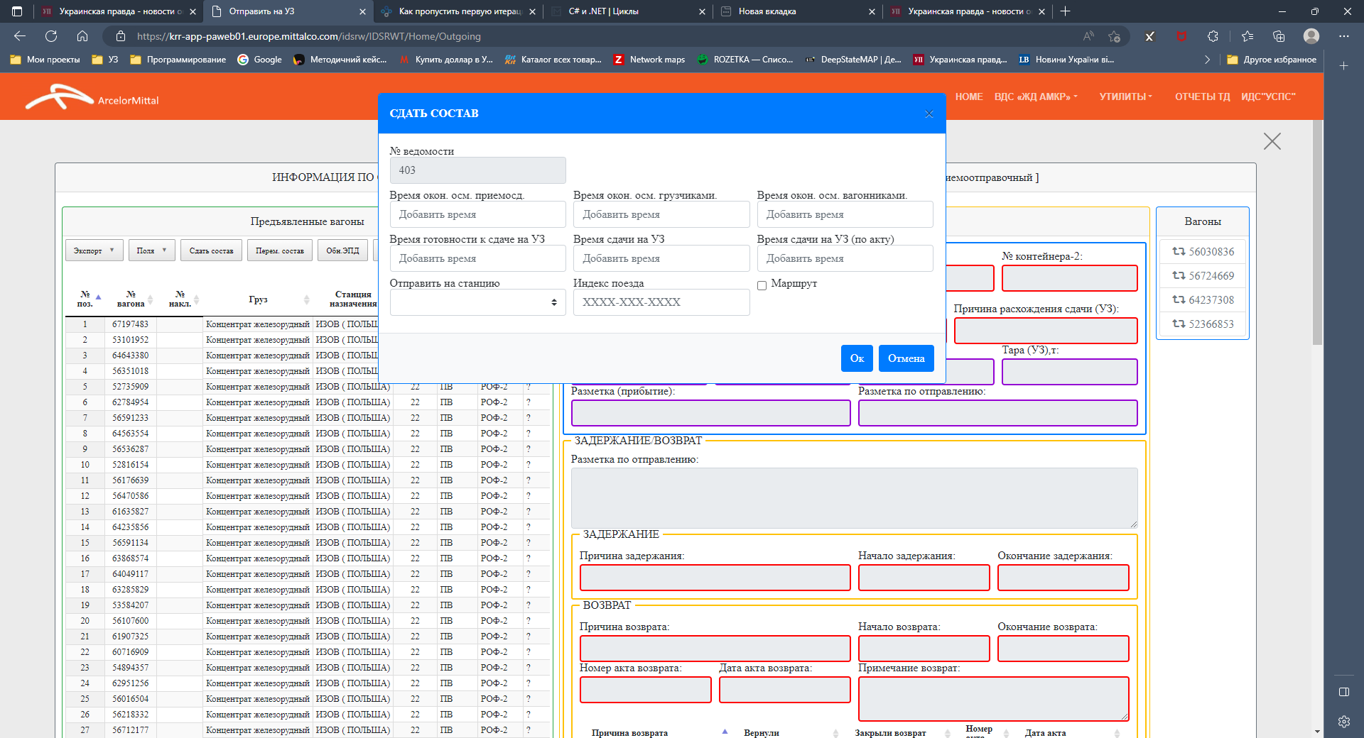

Кнопка ок - вызывает : **this.ids_wsd.postOperationPresentSostav(data, function (result) {}) (**api/ids/rwt/wsd/operation/present/sostav**)**

**->** IDS_RWT_WSDController: PostOperationPresentSostav

-> IDS_WIR: int OperationPresentSostav(long id_outgoing_sostav, DateTime date_end_inspection_acceptance_delivery,

DateTime date_end_inspection_loader, DateTime date_end_inspection_vagonnik, DateTime date_readiness_uz,

DateTime date_outgoing, DateTime? date_outgoing_act, int status, int station_on, bool route_sign, string composition_index, string user)